Please send this letter by email for the urgent attention of your mp

Use this link to find their address

https://members.parliament.uk/findyourmp

Please copy and paste this letter to insert your details or download a copy to then email to your MP

ADDRESS OF MP

Dear XXX,

I am writing to you to warn of the impending disaster in the hairdressing sector.

And call on you to support a reduction in VAT to 10% for The Hair & Beauty Sector and the wider service and hospitality industry.

You can register your support directly with HMT here, there is specific provision for MP’s in this survey - https://www.smartsurvey.co.uk/s/SpringBudget24/

There is a huge disparity in taxes paid between the two main hairdressing and beauty business models now operating on the High Street, which is hitting the traditional salon owner and the treasury in equal measure.

This, coupled with the on-going challenges of increasing inflation, debt and payroll pressures exacerbated by the recent enforced increases in wages and NVQ salaries as well as the severe decline in customer visit frequency due to the cost of living crisis and post- Covid changes in customer behaviour, is putting the industry in grave peril.

Non VAT paying salons depress sector wide pricing and are forcing VAT paying salons prices to consider adopting similar chair rental models, which will also mean they will no longer be able to employ apprentices (if they don't operate a PAYE scheme). As a result, traditional salons are being driven out of business and are at risk of being unable to pay their taxes, having to charge around 40% more and paying more than double the alternative self-employed business model in taxes.

The vast majority of salon owners feel they are being penalised for doing the right thing but soon will have no choice but to consider changing business models to keep each operator below the VAT threshold, and in doing so, deregistering for VAT and PAYE.

Here are some results from the survey that demonstrate the level of challenge within our industry:

In a time when we are working for little or no profit, this blow is huge.
Our latest survey data:

Suggests that over 50% of business owners are considering closing their business right now

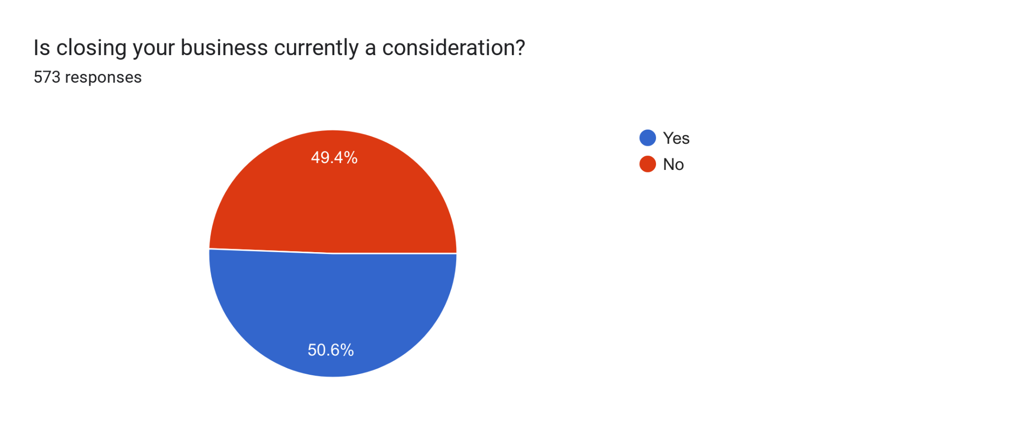

And that confidence is at an all time low with over 57% of respondents having sleepless nights with nearly 1 in 5 having the worst mental health crises ever and close to breakdown.

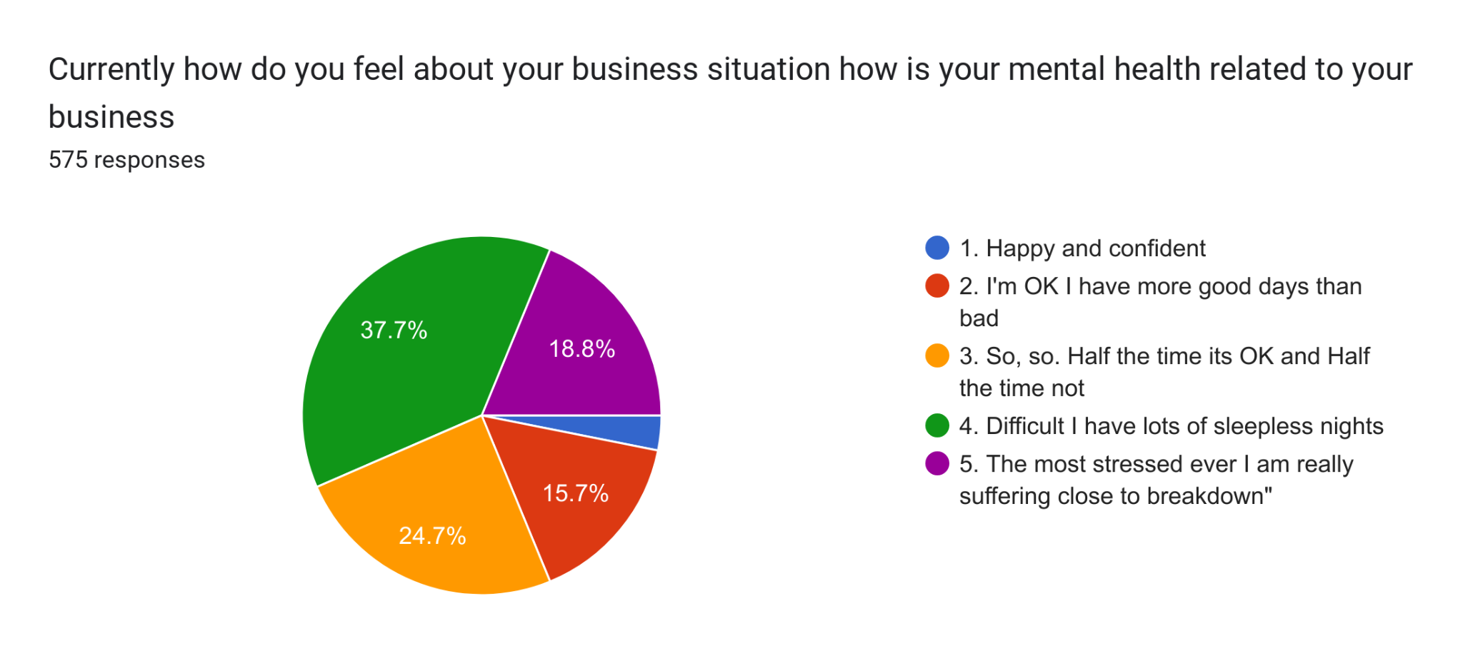
Future skills are also at risk with just 4% of salons saying the that they will be able to maintain the levels of NVQ training following the recent Autumn Statement

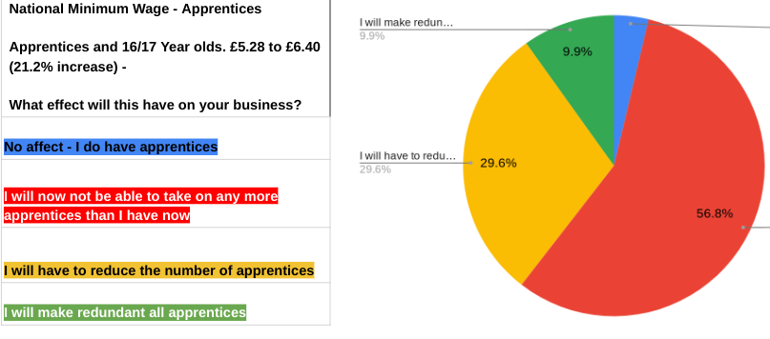

We are an industry with PAYE employers and VAT registered businesses on the brink of collapse.

Without an immediate reduction in VAT to 10%, around 50% of our industry employers will go out of business, resulting in millions of pounds in government backed loans being unpaid and a switch away from VAT registration and PAYE employment, with a further drastic reduction of NVQ apprenticeships within our sector (latest figures: down from circa 17,000 in 2016/7 to the current rate of approx 5,000 take-up per annum) .

I trust you will take immediate action to raise this issue on our behalf of our vital sector, the beating heart of the British high street, before businesses like mine are forced to close their doors.

Yours sincerely

XXXXX

XXXX Salon

